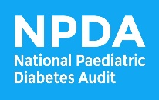
The NPDA Art Competition
Entry Form

Child/young person’s details
First name
Last name
Age | ☐ Under 18 | ☐ 18+
Email (18+ only)
Phone (18+ only)
Parent/carer’s details
(Must be filled out if child/young person is under 18)
Signature
Name
Email
Phone

Thank you for participating.
Best of luck!

If you have any questions, please contact the NPDA Team
npda@rcpch.ac.uk | 020 7092 6137
The NPDA Art Competition
Terms and Conditions

- The NPDA Art Competition is open to all children and young people (up to the age of 25) with diabetes, receiving care from a paediatric diabetes unit.

- Only one piece of artwork per child/young person will be accepted.

- Artwork must be no bigger than A4 sized, submitted in colour, with a completed entry form, to be accepted as an entry.

- Artwork can be created from any choice of media (e.g. paint, pencil, digital, collage).

- Entry into the competition is free, but all materials used must be provided by the participant.

- Entries must be sent to the NPDA via email to: npda@rcpch.ac.uk or by post to:
NPDA Art competition
RCPCH
5 – 11 Theobalds Road
London
WC1X 8SH

If the artwork is submitted as a scanned image or photo, it must be of good quality, clear, and free of shadows.

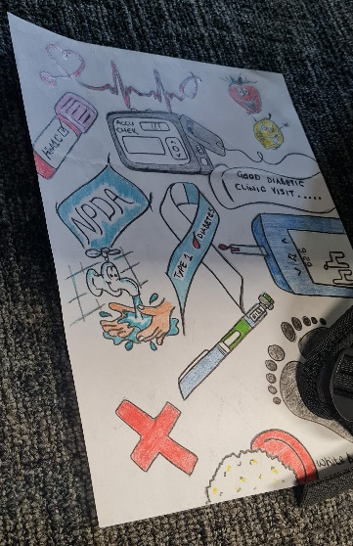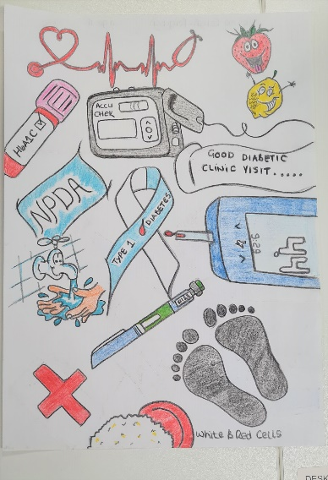

- All artwork must be the original idea of the entrant and not infringe on anyone else’s copyright.

- All artwork submitted for the competition will be reviewed by a panel of judges. The winner will be decided by this panel who will be looking for originality, aesthetic appeal, relevance to the theme ‘My Journey with Diabetes’ or ‘My Diabetes Team’. and general fit with the overall look and feel of our reports.

- The decision of the judging panel is final and binding on all entrants. No correspondence to query the decision will be entered into.

- Prize:
One winner will be chosen from the entries received to the NPDA Art Competition. The winner will have their artwork displayed on the front cover of the NPDA Core Audit on 2024-25 data (publication in 2026) and will receive an One4All gift card with a value of £50.

- The closing date of the NPDA Art Competition is Monday 19 January 2026, 9am. Entries will be accepted up to and including this point.

- The winner will be notified by Monday 26 January 2026.

- No cash alternative to the prize is available and the prize is non-transferable.

- By entering the NPDA Art Competition, all entrants consent to the NPDA’s and RCPCH’s use of their full entered artwork, and sections of it, free of charge, in any future publications, including print, digital, and social media, and also consent to being publicly acknowledged by first and last name, as provided on the entry form.

- If a parent/carer’s signature, name and contact details are included on the entry form, the NPDA and RCPCH will consider this as parental consent for a child or young person’s entry who is under the age of 18 years.

- The NPDA and RCPCH are not responsible for any entries that are late, lost or delayed.

- All artwork and details provided on entry forms will be held by the NPDA on RCPCH servers. If you wish to withdraw your consent, entry and details at any point, please contact npda@rcpch.ac.uk.

- Any gift vouchers awarded may represent taxable income. The RCPCH offers no advice to recipients on tax arrangements but a P443 can be provided on request.

